D2L Turnitin Online Grading

Turnitin Online Grading

There are two parts to Turnitin: Similarity score and Online Grading. The Similarity score is generated automatically by Turnitin, but if you enable Turnitin’s Online Grading, scores can be entered by the teacher in Turnitin and synced back into D2L. (This feature is optional. You can use D2L’s Evaluate button instead of using Turnitin’s Online Grading.)

If you enable Turnitin Online Grading, you will see a notation of “No Score.” This indicates that no score has been entered in Turnitin, or that the score has not been synced back to D2L.

Before proceeding, it is important to note that for students to easily see their Turnitin score, we advise that you add a “Grade Out Of” value on the assignment folder. Linking the assignment to a D2L grade item is optional.
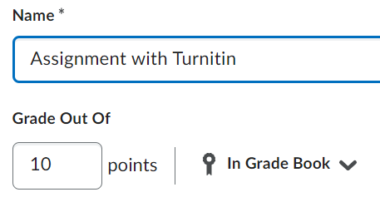

Enable Online Grading
- Click the arrow next to the folder and click Edit
- Click the Evaluation and Feedback menu.
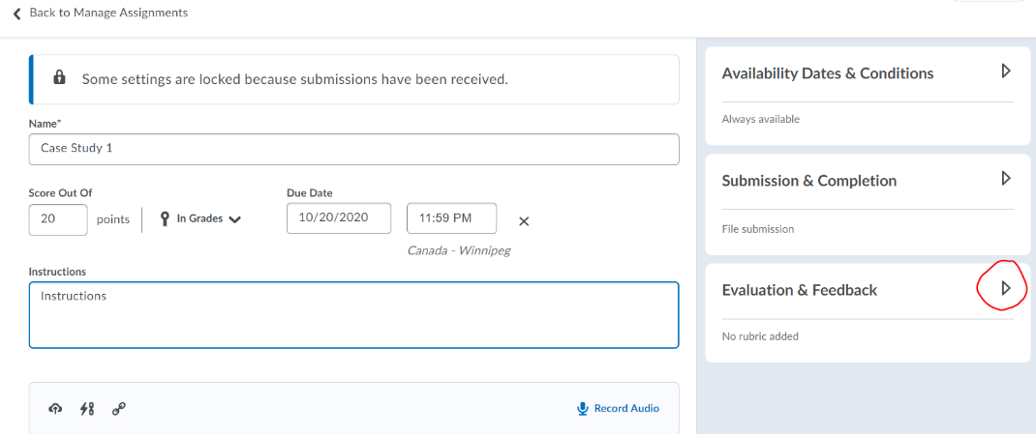
- Click the Manage Turnitin link.
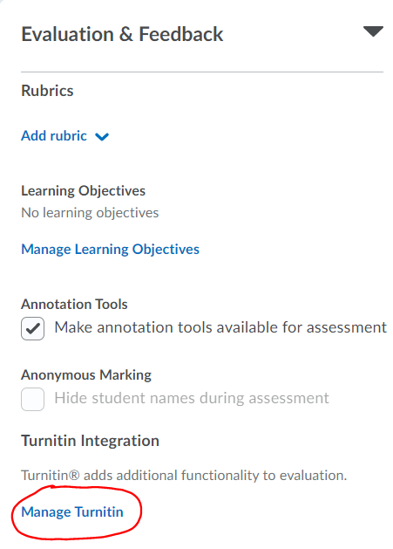
- Select Enable Similarity Report
- Select Enable Online Grading, and
- Select Automatically sync grades as Draft in Brightspace
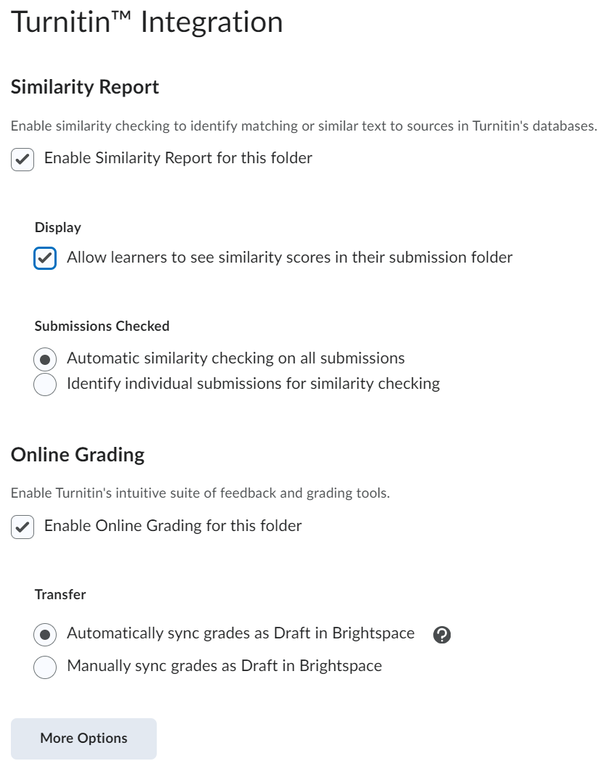

- After making your selections, scroll down and click the More Options button and select additional options as desired. (see Turnitin Basics Tutorial for more information.)

View Similarity Report and Assess using Turnitin Online Grading
- To view the similarity report and to enter a score in Turnitin Online Grading, click on the similarity score or click the edit (pencil) icon next to a student’s submission.

- A new tab opens that takes you into the Feedback Studio. You can leave comments and use the markup tools in Turnitin as desired. Note the help button in the upper right corner and the tools along the right-hand side of the page. You will also see a score at the top of the page.
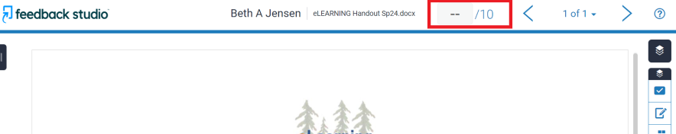

- When you enter a score in Turnitin, the score can be automatically or manually transferred back into D2L in “draft” mode (depending on what you selected when setting up the assignment). If you chose automatically, you may need to refresh your web page.
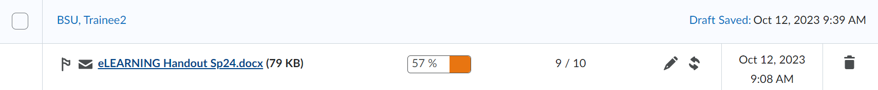
NOTE: If you chose to manually transfer the scores back, you will need to manually click the sync button to get the scores to transfer, and you will also need to manually enter the score in the “Evaluate” area.
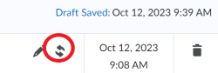

- After the scores are synched back to D2L, they need to be published. Click the Draft Saved button, add any additional comments, and then click Publish. If you have a grade item in D2L that is connected to the assignment, the score will also transfer to the gradebook when published.

For more information about Turnitin, check out this these instructor resources.

Additional Resources
Go to the eLearning Website for detailed tutorials on many D2L topics.

