D2L Assignments with Turnitin

Assignments with Turnitin Basics
The Assignments tool provides a convenient way for students to electronically submit assignments. You can enable Turnitin on any assignment folder, which will compare student submissions to a vast repository of student papers and websites and generate a similarity report. This report helps you determine if parts of the submission were plagiarized.

Enable Turnitin for Assignment Folders
- Edit or Create an Assignment Folder
- Click the Evaluation and Feedback menu.
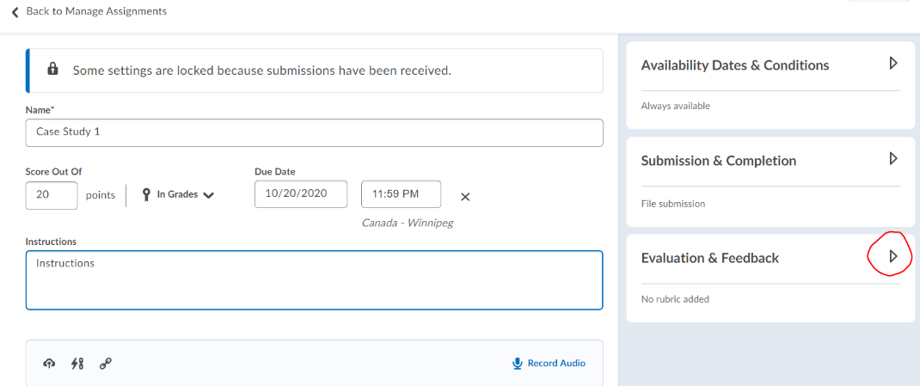
- Click the Manage Turnitin link.
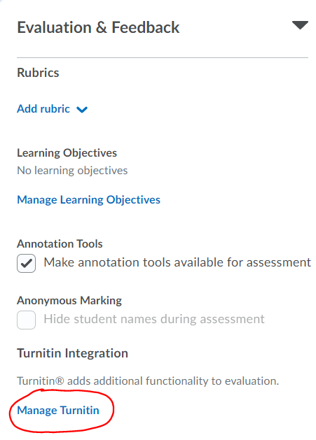

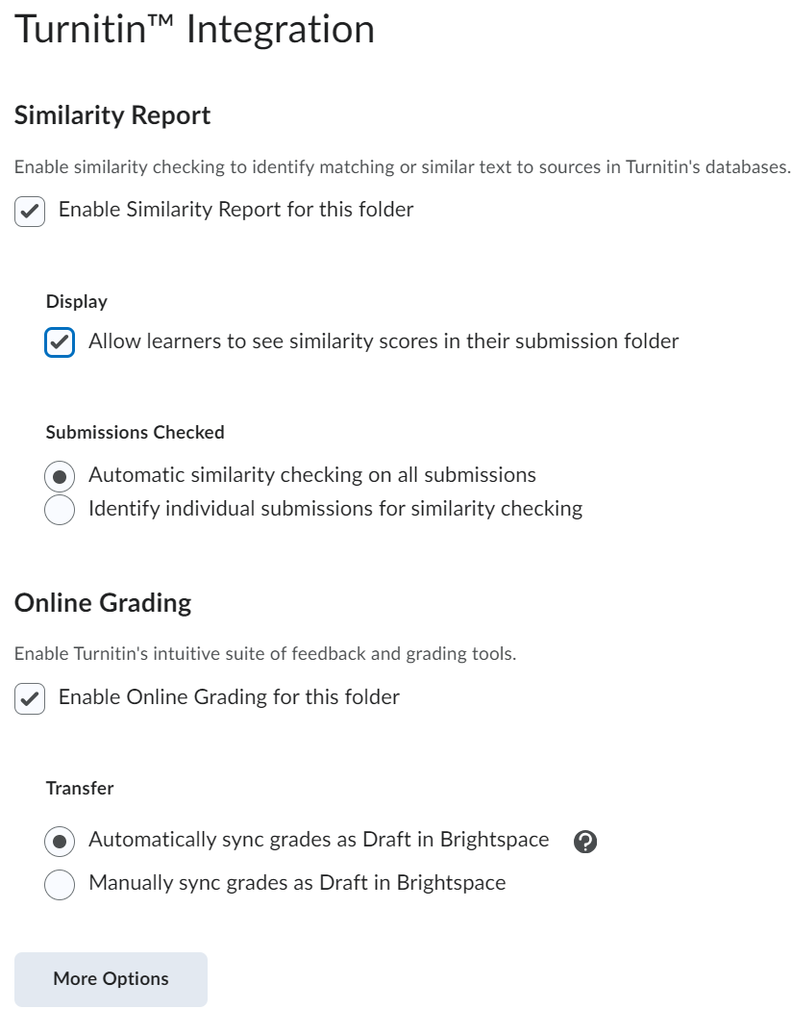
- After making your selections, scroll down and click the More Options button.
- Under Submission settings, select where to submit the papers. Click the question mark icon next to any option to see more information.
  - Standard Paper Repository.
  - Do not store the submitted papers (Use this option if this is a first draft of the student’s paper).
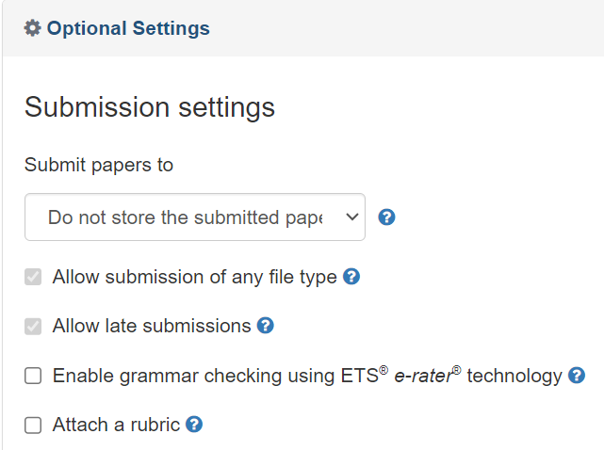
- If you want to check grammar, click the box for Enable grammar checking and select additional options.
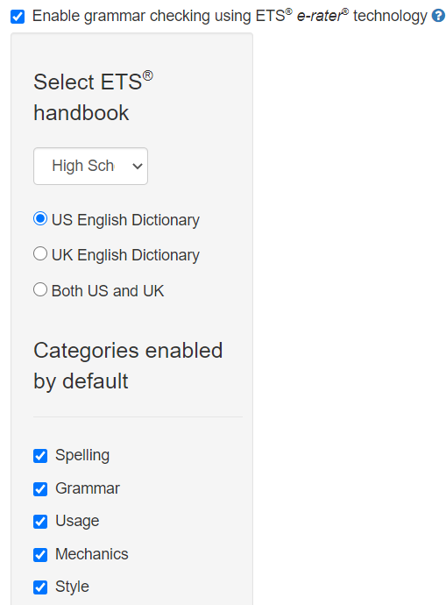
- Continue setting your preferences.
  - Compare against
  - Similarity Report
  - [optional] Exclude assignment template
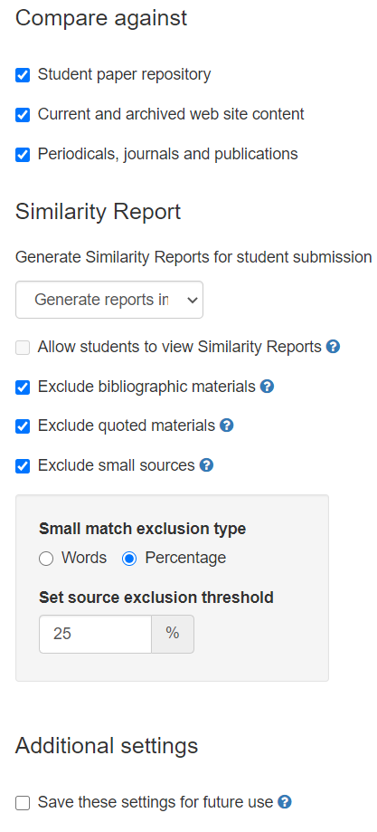
- Click the box to Save these settings for future use.
- Click Submit.
- Click Save on the Turnitin options.
- Click Save and Close for the Assignment folder.

View Student Submissions and Leave Feedback
When you use Turnitin, you have two options for assessing student submissions:
- Use the Assignment folder Evaluate page as you do with other assignments.
- Use the Turnitin Online Grading feature.

Whatever method you choose, you can view a student’s similarity report by clicking on the similarity score percentage or by clicking the pencil icon next to a student’s submission. The notation “No Score” indicates that no score has been entered inside of Turnitin, or that the score has not been synced back to D2L.

OPTION 1: View Similarity Report and Assess using D2L Evaluate

- View the similarity report in Turnitin feedback studio by clicking on the similarity score or click the edit (pencil) icon next to a student’s submission.

- A new tab opens that takes you into the Feedback Studio. You can leave comments and use the markup tools in Turnitin as desired. Note the help button in the upper right corner and the tools along the right-hand side of the page.
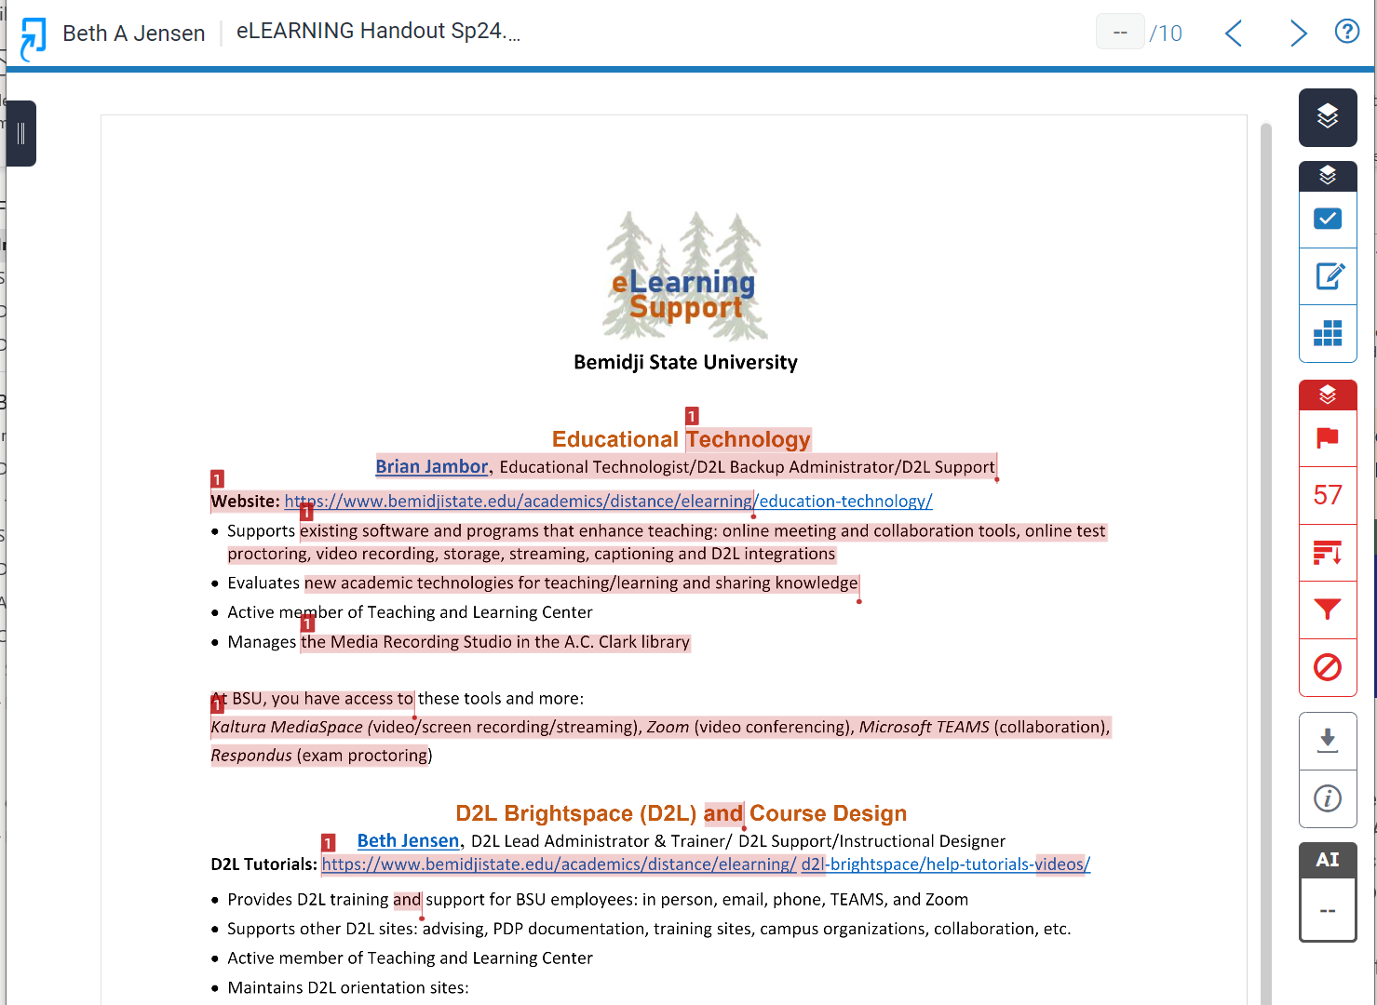
- When finished viewing the report, close the feedback studio, return to the D2L Assignment submission page and click on the Evaluate button for the student.

- Enter a score and feedback and then click Publish.

OPTION 2: View Similarity Report and Assess using Turnitin Online Grading

- To view the similarity report and to enter a score in Turnitin Online Grading, click on the similarity score or click the edit (pencil) icon next to a student’s submission.

- A new tab opens that takes you into the Feedback Studio. You can leave comments and use the markup tools in Turnitin as desired. Note the help button in the upper right corner and the tools along the right-hand side of the page. You will also see a score at the top of the page.
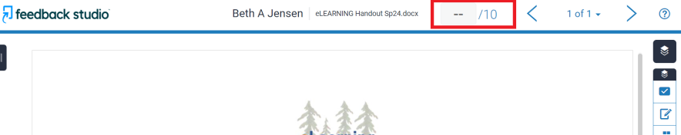

- When you enter a score in Turnitin, the score can be automatically or manually transferred back into D2L in “draft” mode (depending on what you selected when setting up the assignment). If you chose automatically, you may need to refresh your web page.
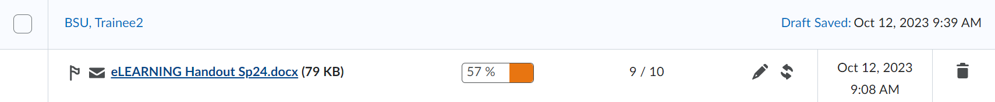
NOTE: If you chose to manually transfer the scores back, you will need to manually click the sync button to get the scores to transfer, and you will also need to manually enter the score in the “Evaluate” area.
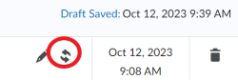

- After the scores are synched back to D2L, they need to be published. Click the Draft Saved button, add any additional comments, and then click Publish. If you have a grade item in D2L that is connected to the assignment, the score will also transfer to the gradebook when published.

For more information about Turnitin, check out this these instructor resources.

